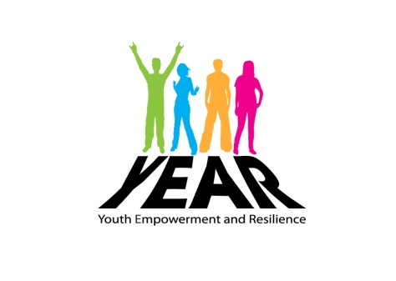
Name:______________________________
Review form for young people

Congratulations
on completing a programme of events with YEAR

During your time with the YEAR project have you:

- Completed one or more accredited qualification? YES/NO
- Completed one or more other courses? YES/NO
- Attended an interview for a job? YES/NO
- Got a job since starting with YEAR? YES/NO
- Taken part in a voluntary activity or MV Award YES/NO
- Help plan/take part in a community activity/event? YES/NO
- Met new people from different backgrounds YES/NO
- Given feedback on what you want/need? YES/NO
- Attended a YEAR celebration event or conference? YES/NO
- Will you be working, at school/college or volunteering this year? Please circle: Working School/college Volunteering
On a scale of 1-5 how would you rate (were 1=poor & 5=very good)
1 - - - 5
- The YEAR project programmes o o o o o
- The YEAR youth workers o o o o o
- Opportunities to try new things o o o o o

