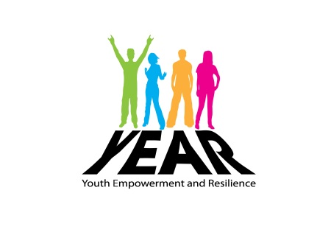
Parent’s baseline project Evaluation Form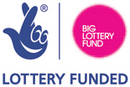

Name of Young Person: ___________________________

Name of Parent/Guardian: __________________________

How would you prefer us to keep in touch with you? | Text/Phone | Letter |  | Visit | Email
Would you like to receive information from YEAR or relevant organisations for parents/carers: if Yes how? | YES |  | NO
 | Text/Phone | Letter |  | Visit | Email
Did you know we have a Facebook page where you can see photos of your young person and info relevant to parents? | YES |  | NO
Do you want any information or support to tackle challenges of daily life for you or your family? e.g. drug/alcohol, challenging behaviour, financial difficulties, school. | YES |  | NO
Would you be willing to attend occasional group activities for parents and young people together? | YES |  | NO
Would you like to attend activities/training for parents organised through the YEAR project? | YES |  | NO
Is there anything in particular you would like your young person to work on during their time with YEAR?
Is there anything you think we need to know about your young person to help us best support them during their time with YEAR.

Date: _________________________

Thank you for taking the time to complete this survey please contact us if you need further information or support on 02870344934.

